Russell Bjella

ASEN 6008 – Homework 2

2/8/17

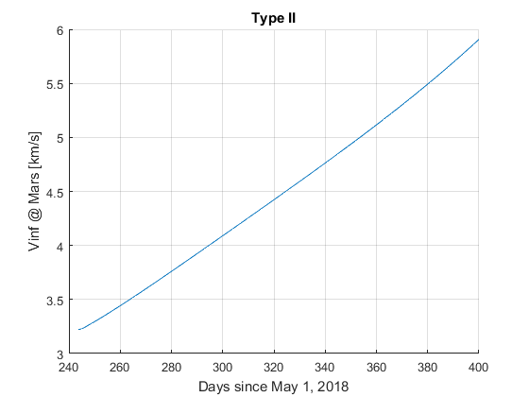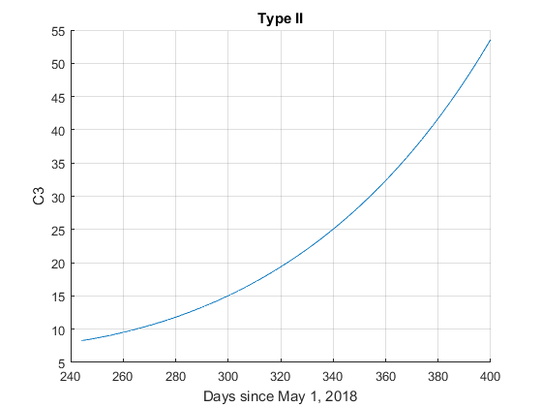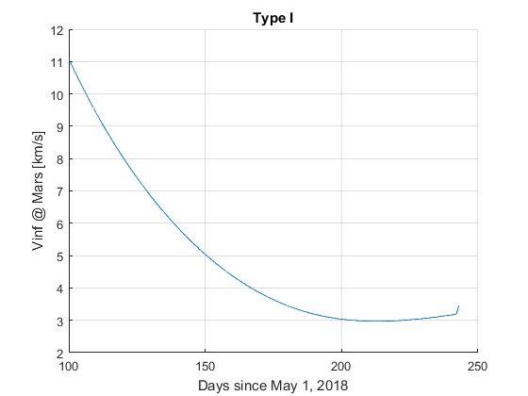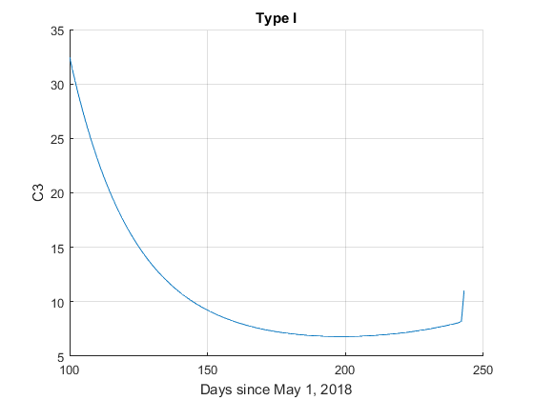**Problem 1**

1. Minimum type 1 C3: 6.8044 km^2/s^2, arrives 198 days after departure
2. Minimum type 1 Vinf @ Mars: 2.9697 km/s, arrives 213 days after departure
3. Minimum type 2 C3: 8.3332 km^2/s^2, arrives 245 days after departure
4. Minimum type 2 Vinf @ Mars: 3.2228 km/s, arrives 244 days after departure

**Problem 2**

The actual Dawn mission departed Vesta on September 5, 2012 and arrived at Ceres on March 6, 2015, a travel time of 912 days. However, based on the assumptions of an impulsive burn from Vesta at the transfer trajectories perihelion and an encounter with Ceres at its perihelion, the trip should only take 574 days. The discrepancy is partially caused by perturbations such as massive bodies (Jupiter, Mars, etc.) and solar radiation pressure, but the primary difference is that Dawn used ion thrusters, which provide extremely low thrust over very long burn times (weeks or months).